**Experiment-1**

**THEORY:**

What is a microprocessor?

Microprocessor is programmable, clock driven, register based electronic device that reads binary information from storage device called memory, accepts binary data as input and process the data according to instructions and produces binary result as an output.

Why 8085 microprocessor?

It is a microprocessor with simple architecture and adequate instruction set that enable to understand the programming concepts of hardware. Having learned the basic concepts of 8085 microprocessor, student can adapt to advance microprocessor and microcontroller environments very easily.

About 8085 microprocessor

The 8085 is an 8-bit microprocessor capable of addressing 64KB of memory. The device has 40 pins, requires +5V supply, and generally operate with a 3 MHz single-phase clock.

What is DYNA -85?

MICROFRIEND DYNA-85LU is a single board computer based on 8085A CPU designed especially for training and development applications. It is equally useful for novice as well as development engineers for studying the 8085A CPU and developing various products based on the 8085A.

**APPARATUS:**

1. Computer system

**MICROFRIEND DYNA-85LU HARDWARE OVERVIEW:**

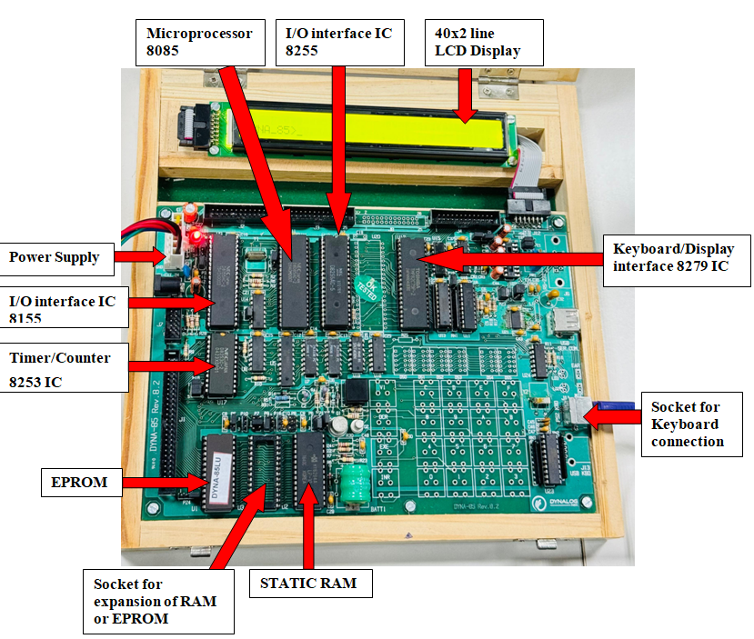

**FEATURES OF MICROFRIEND DYNA-85LU KIT:**

* **CENTRAL PROCESSING UNIT:**

MICROFRIEND DYNA-85LU is based on the Intel 8085A high performance CPU operating at 3 MHz

* **MEMORY:**

Powerful system monitor has been provided on a **27128 EPROM** covering 16K bytes. This monitor included all standard command, functions, utility subroutines and serial interface routines as well as line assembler/ dis-assembler.

A 62256 **battery backup RAM** has been provided on board for inputting and executing programs.

One 28 pin socket is provided for memory chips so that further expansion of RAM / ROM is possible up to a maximum of 56K.

* **LCD DISPLAY AND KEYBOARD INTERFACE:**

An IBM compatible keyboard with 101 keys and 40x2 line LCD display is provided for interface with the system using **89C2051** micro-controller interface module. This interface is using SID/SOD lines of CPU, to simulate it in virtual serial mode.

* **PARALLEL I/O INTERFACE:**

46 parallel I/O lines are provided on board, 22 from 8155 and 24 from 8255. These lines are brought onto connector J2 ( for 8155 ) and J3 ( for 8255 ) and J8 (for 8255) optional.

* **SERIAL I/O INTERFACE:**

Serial I/O interface is available through RS232C compatible port. The SID and SOD lines are used under software control for serial operation i.e. for hooking up this trainer kit to serial port of a PC.

* **TIMER:**

Three channels of 8253 chips, a 16 bit TIMER / COUNTER and one channel of 14 bit TIMER /COUNTER of 8155 are provided on board. All lines from 8253 are provided on connector J7 and lines from 8155 are provided on J2.

* **EXPANSION SLOT:**

All address, Data, Control and Hardware interrupt lines are brought on to a 50 Pin FRC connector for system expansion. These lines are un-buffered so user has to take care while expanding their system.

* **MEMORY MAPPING:**

The MICROFRIEND DYNA-85 has a flexible memory map, and for your convenience for program development, the RAM has useful features such as battery back-up**.**

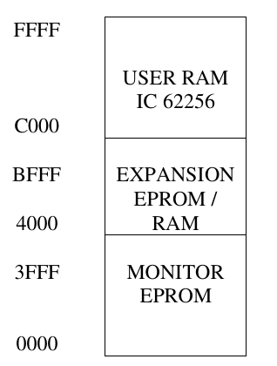

**0000H TO 3FFFH :**

Monitor EPROM socket. Monitor 27128 is located at 0000H to 3FFFH

**4000H to BFFFH:**

This Socket is used for user expansion of EPROM & RAM. EPROM’ s like 2716 / 2732 / 2732 / 2764 / 27128 / 27256 or RAM’ s like 6116 / 6264 / 62256 can be installed by suitable strapping.

**C000H to FFFFH:**

User RAM socket. The 8K user RAM IC 62256 is located at C000H to FFFFH

**SAMPLE PROGRAM TO LOAD AND EXECUTE ON MICROFRIEND DYNA-85LU KIT**

Load the Accumulator with 44h and copy the content of register A into register B.

|  |  |  |  |  |
| --- | --- | --- | --- | --- |
| **Address** | **Hex**  **Code** | **Label** | **Mnemonics** | **Comments** |
|  |  |  |  |  |
|  |  |  |  |  |
|  |  |  |  |  |
|  |  |  |  |  |

**Programing in 8085 simulator:**

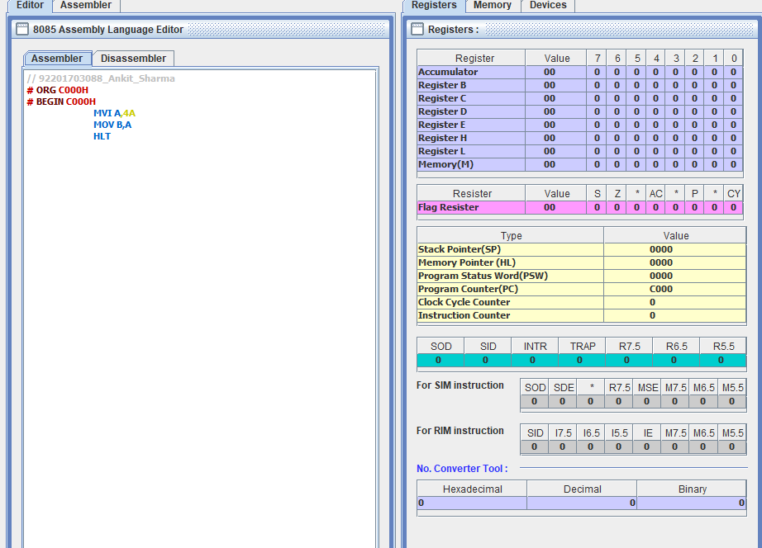

**8085 Assembler:**

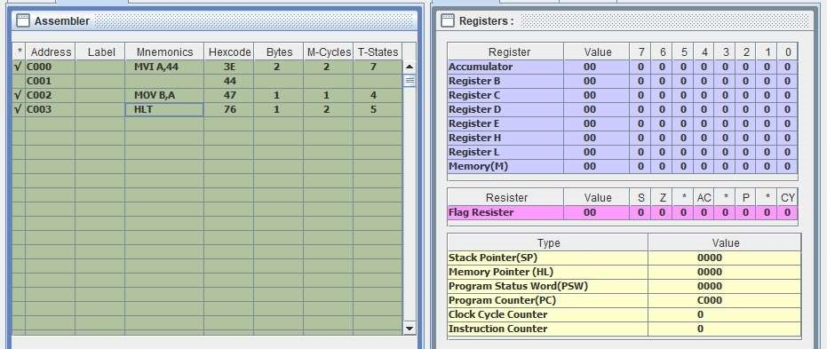

**8085 Assembler:**

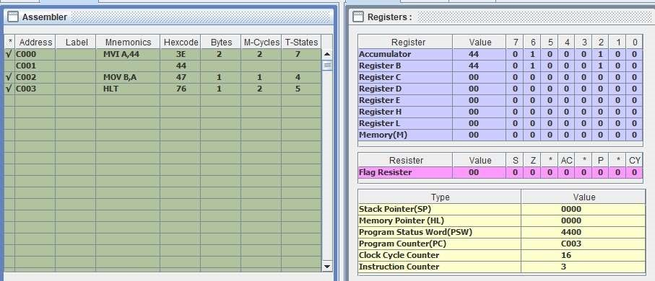

**MVI A,44 timing diagram:**

**MOV B,A timing diagram:**

**PROCEDURE TO LOAD PROGRAM ON MICROFRIEND DYNA-85LU KIT**

STEP 1: Connect the output line of SMPS to the Microprocessor kit

Obs. 1: DYNA_85 appears on the LCD display screen

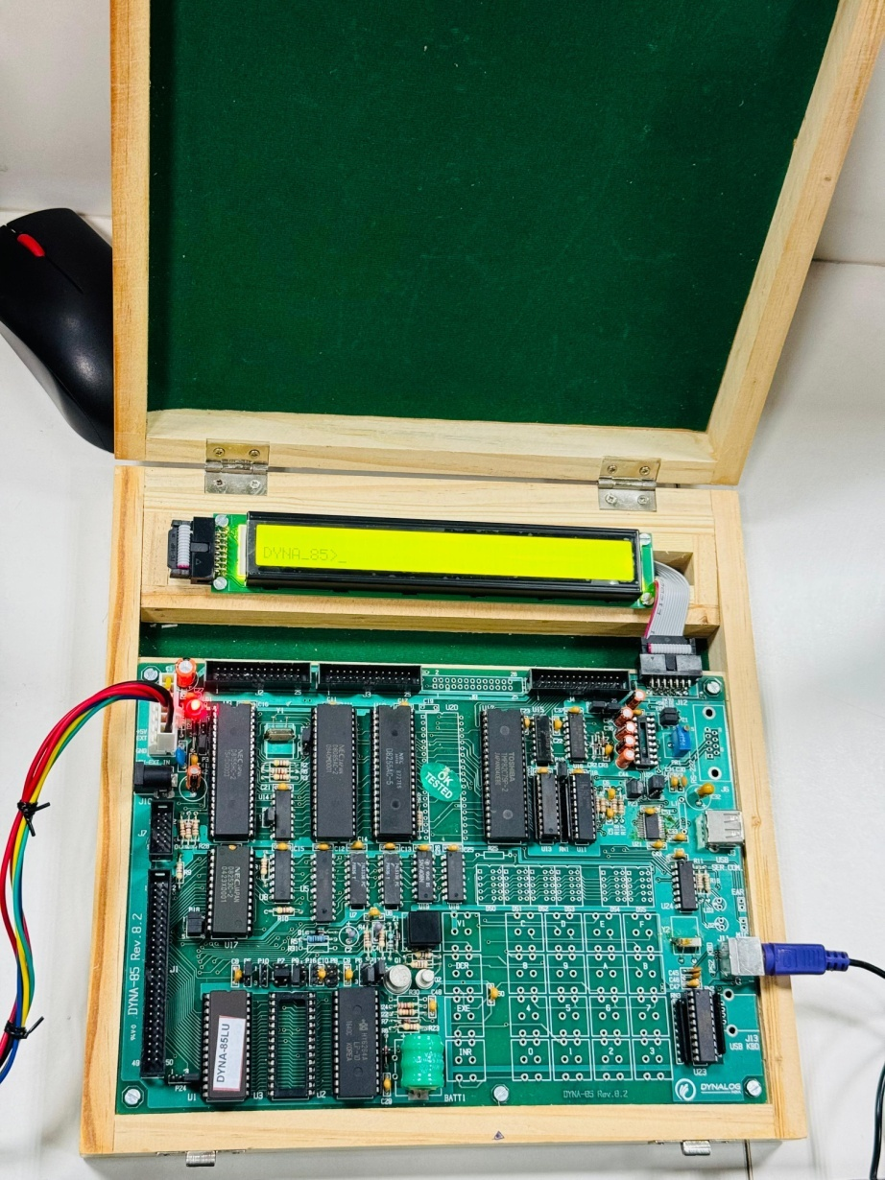

Step 2: Press A followed by the address location. For ex: A C000

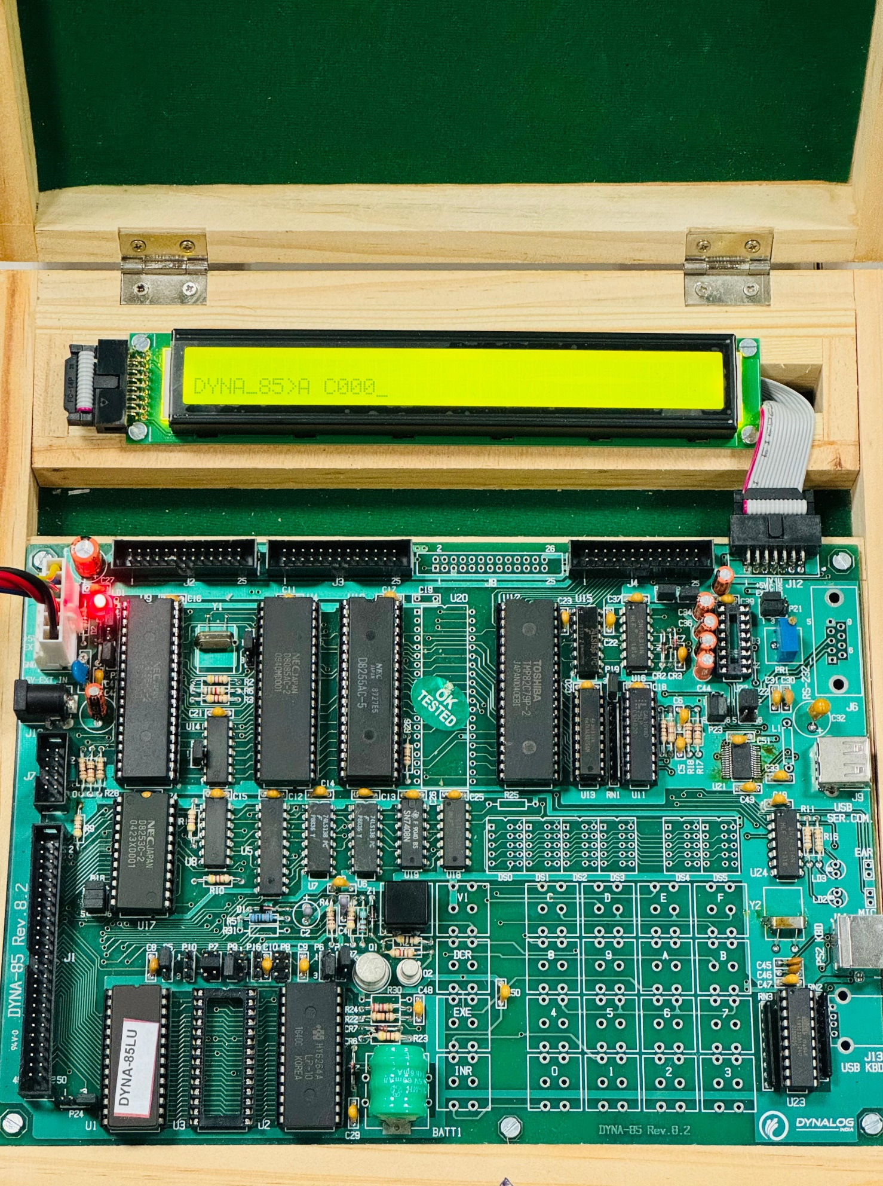

Step 3: Write the programming

MVI A, 44 <Enter>

MOV B, A <Enter>

RST 1 <Enter> <Esc>

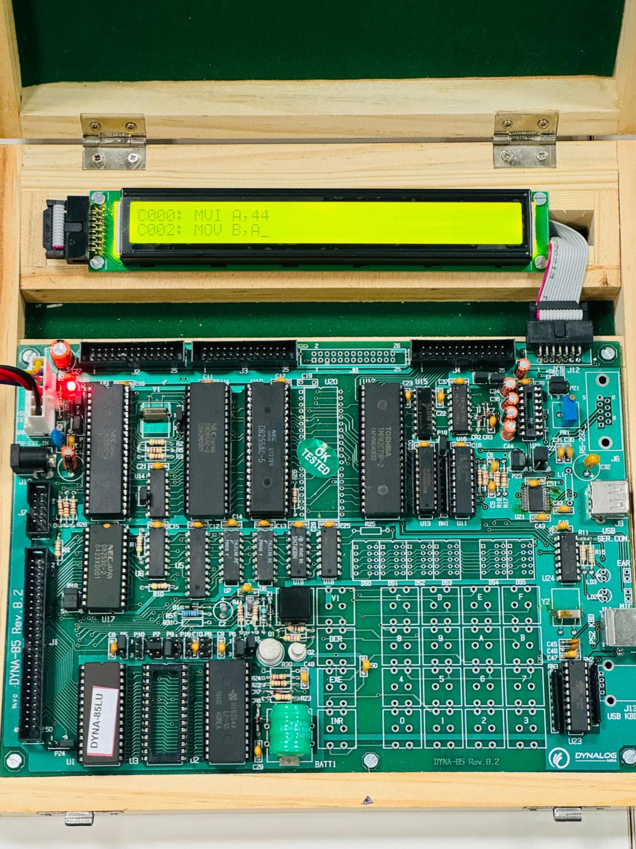

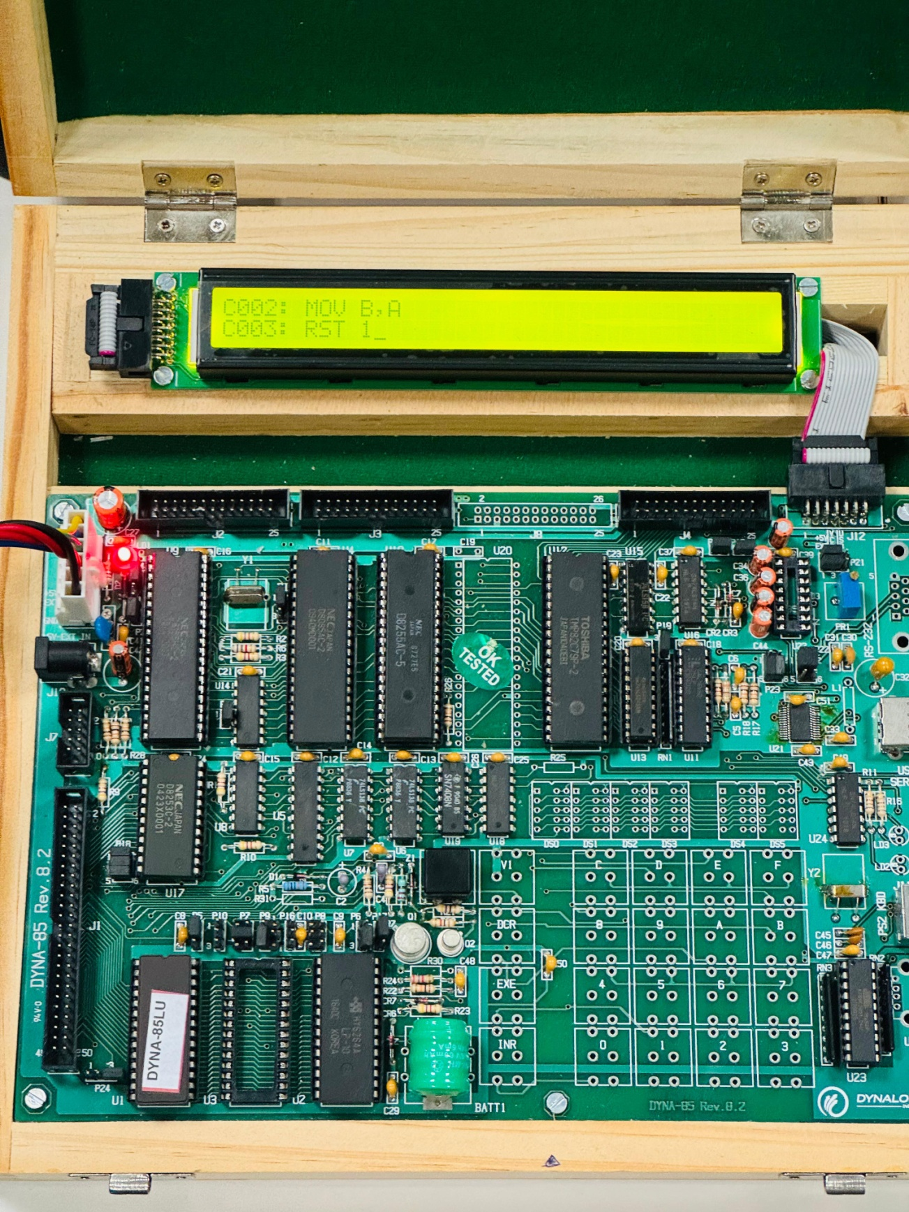

Step 4: To run the program. Write GO “Address” For Ex: GO C000. Press Enter and Space

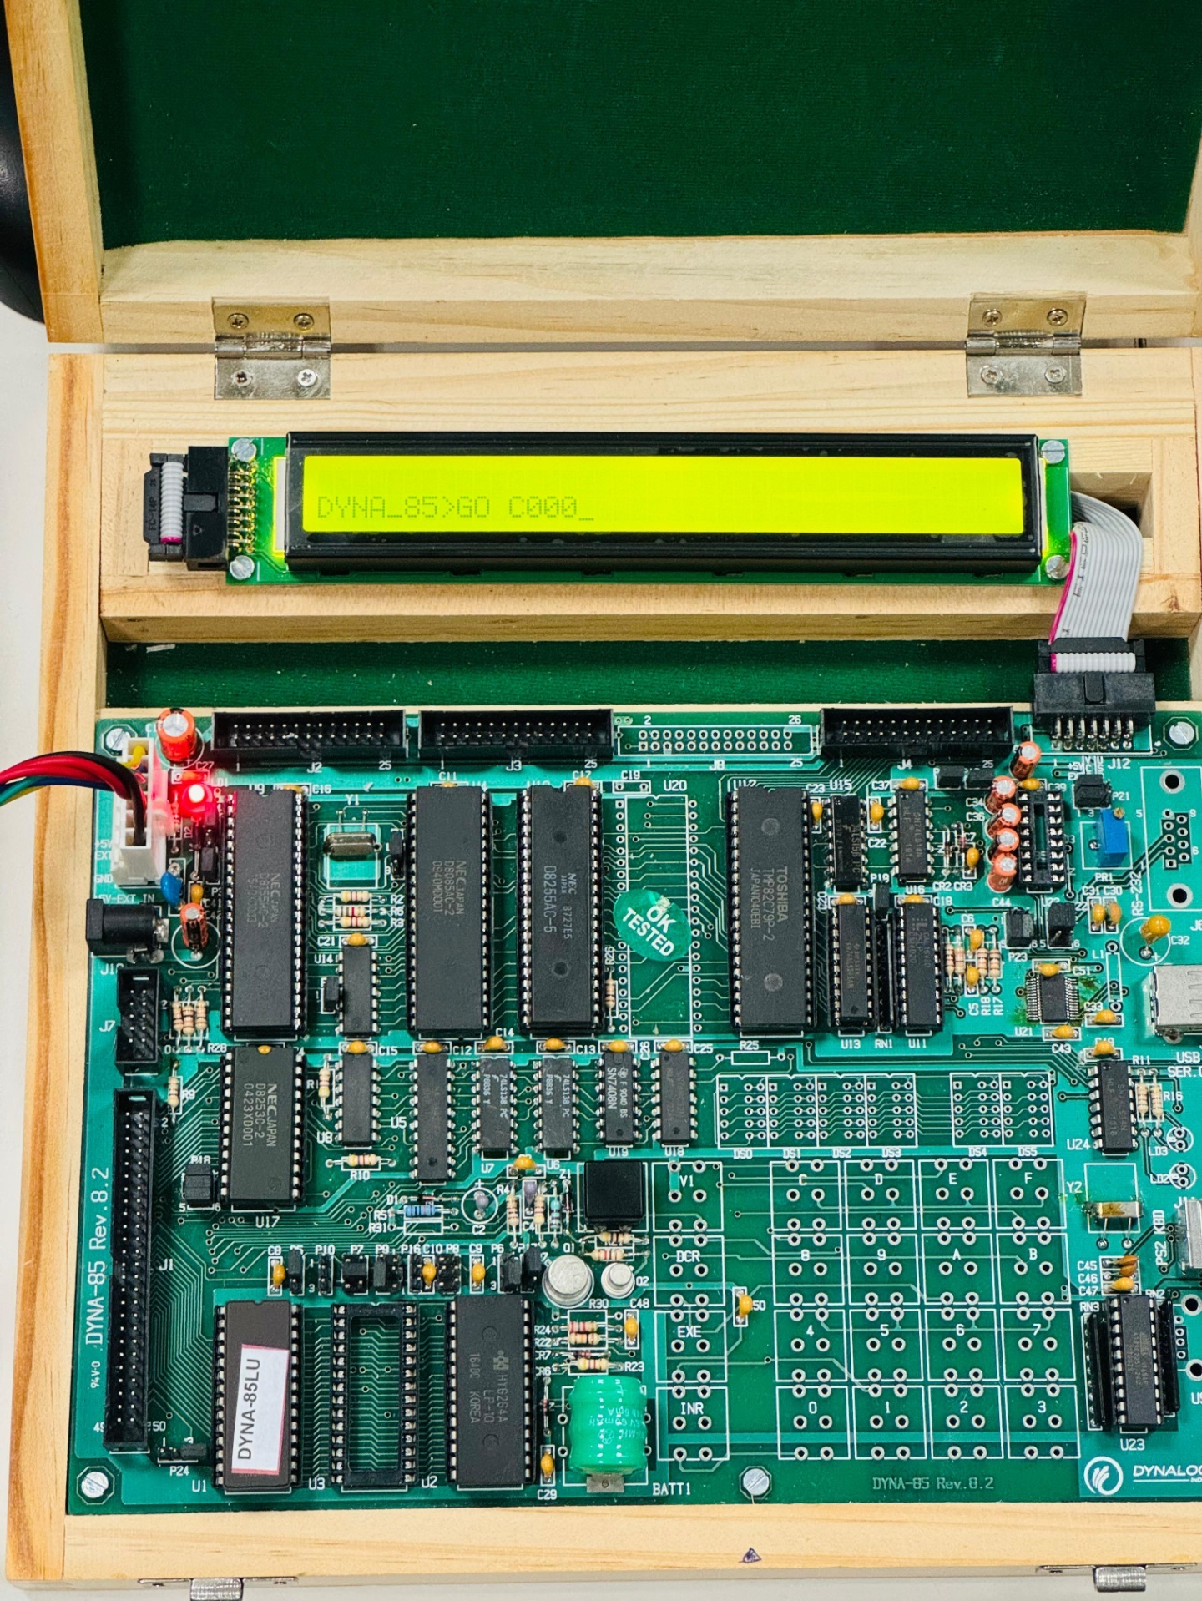

Step 5: To observe the output in the register, Type R and press enter

Obs 2: The output will be displayed on LCD display

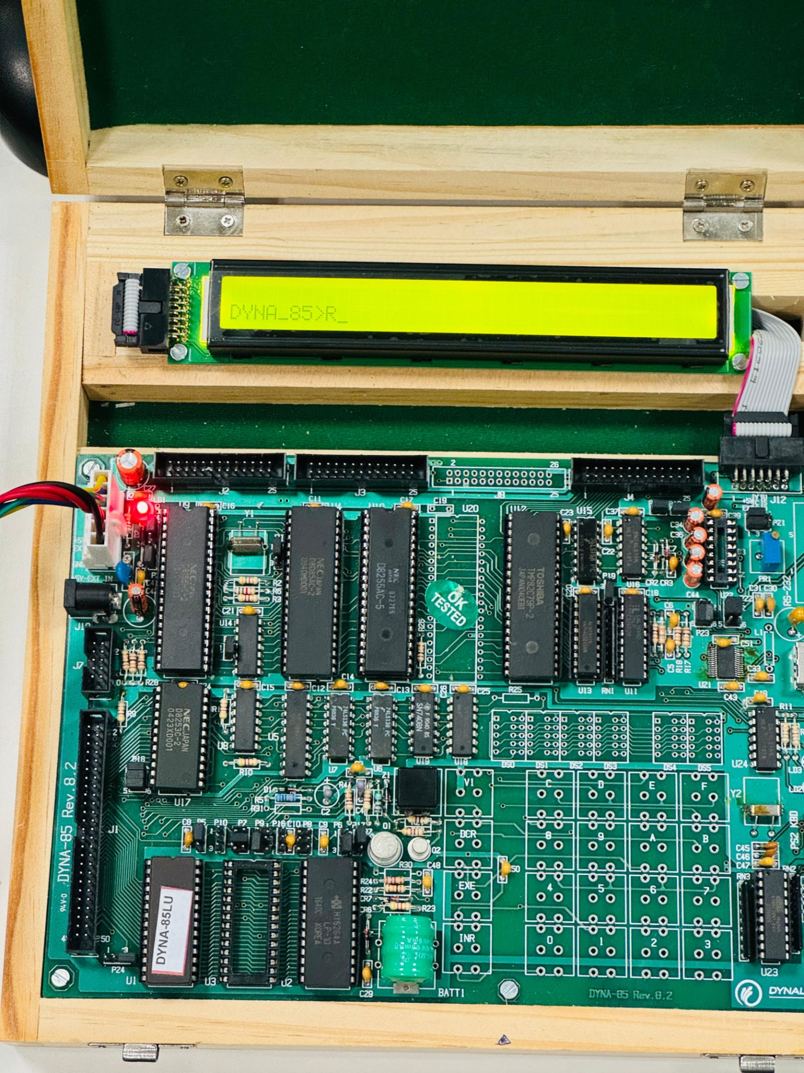

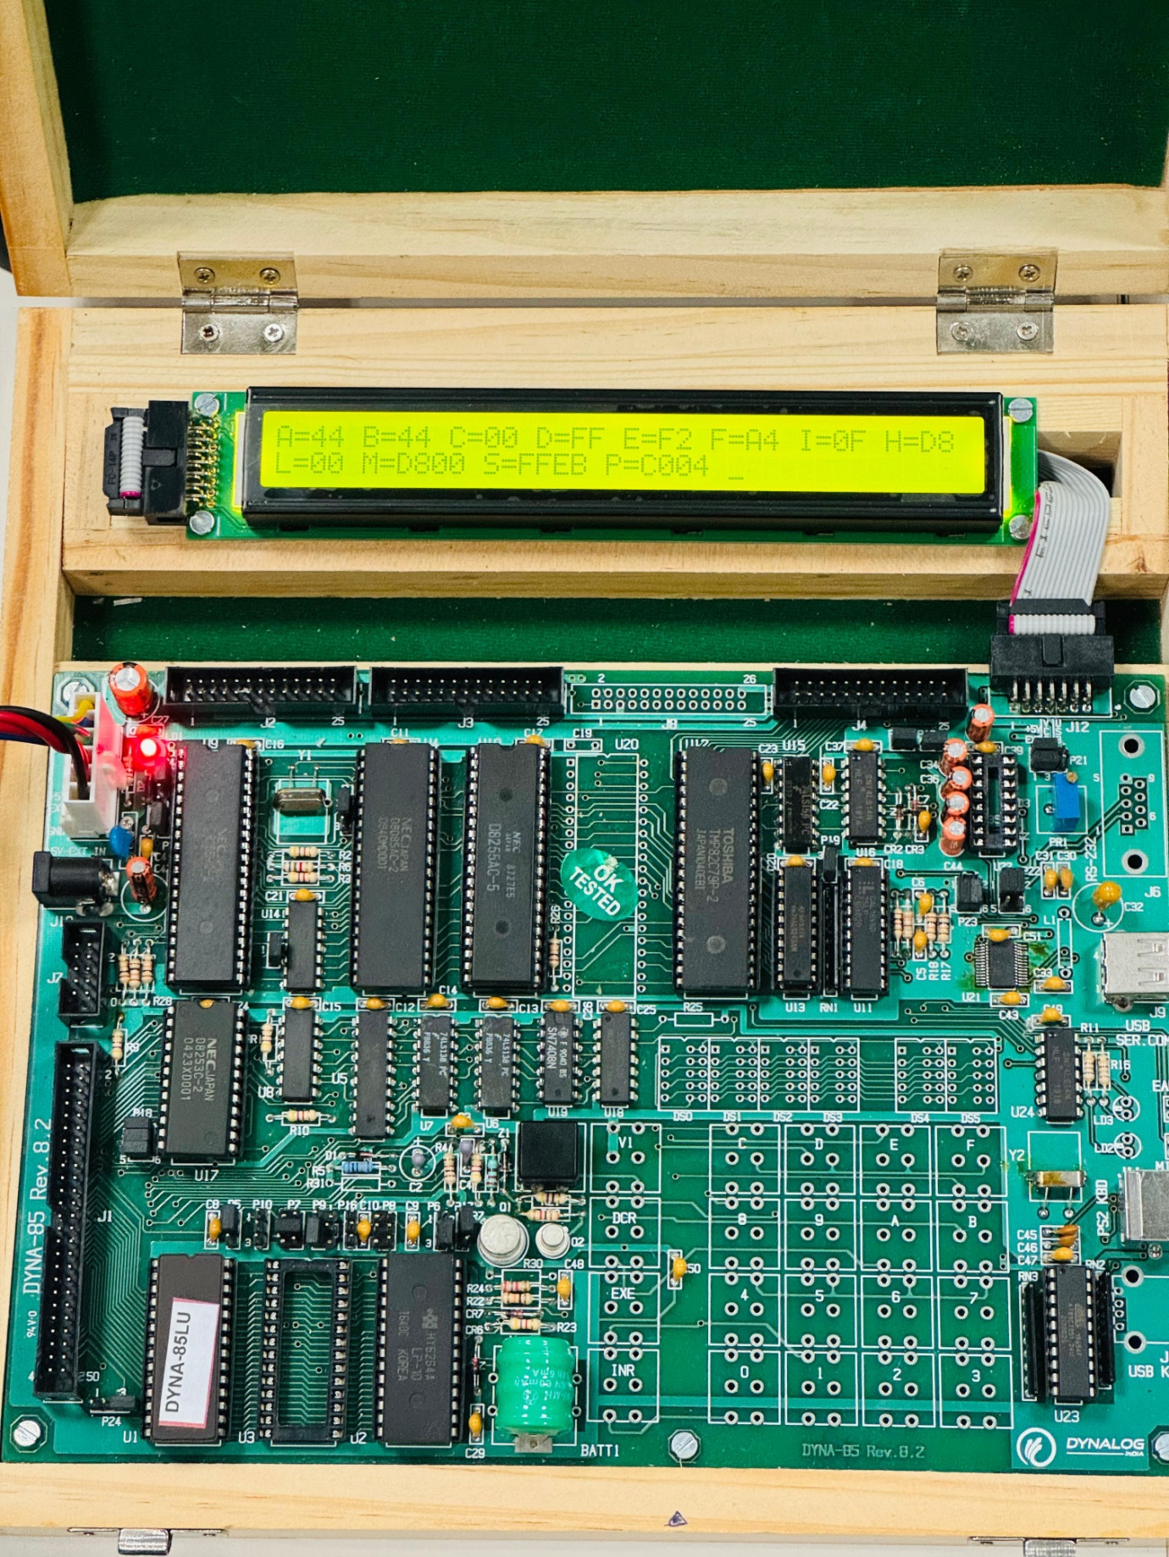

Conclusion: